EaseMyTrip PROJECT

**Functional Requirements Specification**

|  |  |  |  |
| --- | --- | --- | --- |
|  | **Prepared By** | **Reviewed By** | **Approved By** |
| **Name** | **SelenIQ Squad** | **Devathilagai** |  |
| **Role** | **GenC** | **Batch Trainer** |  |

**Table of Contents**

Table of Contents…………………………………………………………..….......II

1. Introduction…………………………………………………………………..…1

1.1 Intended Audience……………………………………………….......1

1.2 Project Scope…………………………...……………………………1

2. Overall Description…………………………………………….……………….1

2.1 Operating Environment……………………...……………………....1

3. Requirements……………………………………………………………...…….1

3.1Login…………………………………………………………………..2

3.1.1Description……………………………………………….....2

3.1.2 Functional Requirements…….………………………….....2

**1. Introduction**

EaseMyTrip is an online travel booking platform. We are currently evaluating six core functionalities of the website, including search capabilities for Cabs, Airport Cabs, Activities, Hotels, and Gift Cards.

**1.1 Intended Audience**

Business Unit (BU) SME

Academy coach

Technical Trainer

**1.2 Project Scope**

This document outlines the system’s business activities at a functional level, along with the governing rules and associated technical requirements—both high-level and detailed. It is informed by the proposed Framework, Business Rules, and Technical Architecture documentation.

As part of the detailed analysis phase, the scope of this document includes:

* Categorization of requirements based on their respective functional domains
* Comprehensive descriptions of each system process, detailing their inputs, outputs, and data transformation logic.

**2. Overall Description**

**2.1 Operating Environment**

Windows operating system

Web application

**3. Requirements**

This part of the requirements document serves to present the "EaseMyTrip for travel booking" of the application and also, we need to extract all the levels in “Web Application”.

**3.1.1 Functional Requirements**

**3.1.1.1 Req0001– Cab Booking: Airport Transfer Flow**

* **Req0001a** – The user navigates to the **Cabs** tab and selects the **Airport Transfer** option.
* **Req0001b** – In the **From** textbox, the user types “Coimbatore” and selects **Coimbatore International Airport** from the auto-suggestion dropdown.
* **Req0001c** – In the **To** textbox, the user types “Munnar” and selects **Munnar** from the auto-suggestion dropdown.
* **Req0001d** – The user selects a **pickup date** from the calendar widget and chooses a **pickup time** from the dropdown list.
* **Req0001e** – Upon clicking the **Search** button, the system displays a list of available cabs along with their respective names and prices.

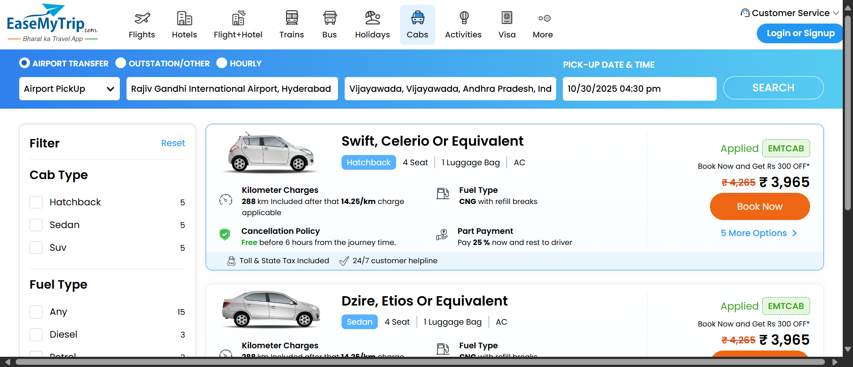

### **3.1.1.2 Req0002 – Cab Booking: Airport Drop Flow**

This requirement describes the user journey for booking an **Airport Drop** via the "EaseMyTrip for travel booking" web application.

* **Req0002a** – The user navigates to the **Cabs** tab, selects **Airport Transfer**, and chooses **Airport Drop** from the dropdown menu.
* **Req0002b** – In the **From** textbox, the user types “Munnar” and selects **Munnar** from the auto-suggestion list.
* **Req0002c** – In the **To** textbox, the user types “Coimbatore” and selects **Coimbatore International Airport** from the auto-suggestion list.
* **Req0002d** – The user selects a **pickup date** using the calendar widget and chooses a **pickup time** from the dropdown.
* **Req0002e** – Upon clicking the **Search** button, the system displays a list of available cabs along with their names and prices.

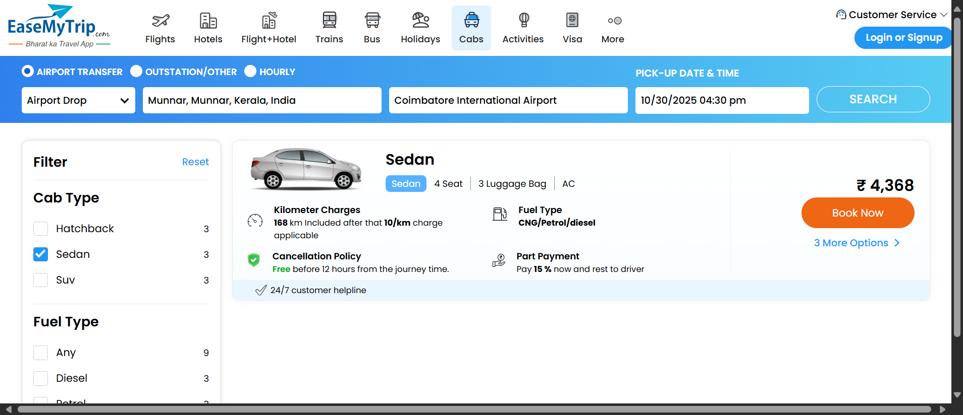

### **3.1.1.3 Req0003 – Cab Booking: Hourly Rental Flow**

This requirement outlines the steps for booking a cab on an hourly rental basis through the "EaseMyTrip for travel booking" web application.

* **Req0003a** – The user navigates to the **Cabs** tab and selects the **Hourly** rental option.
* **Req0003b** – In the **From** textbox, the user types “Munnar” and selects **Munnar** from the auto-suggestion list.
* **Req0003c** – The user selects a **pickup date** using the calendar widget and chooses a **pickup time** from the dropdown.
* **Req0003d** – The user specifies the **rental duration** by selecting the desired number of hours from the **Rent For** dropdown.
* **Req0003e** – Upon clicking the **Search** button, the system displays a list of available cabs along with their names and prices.

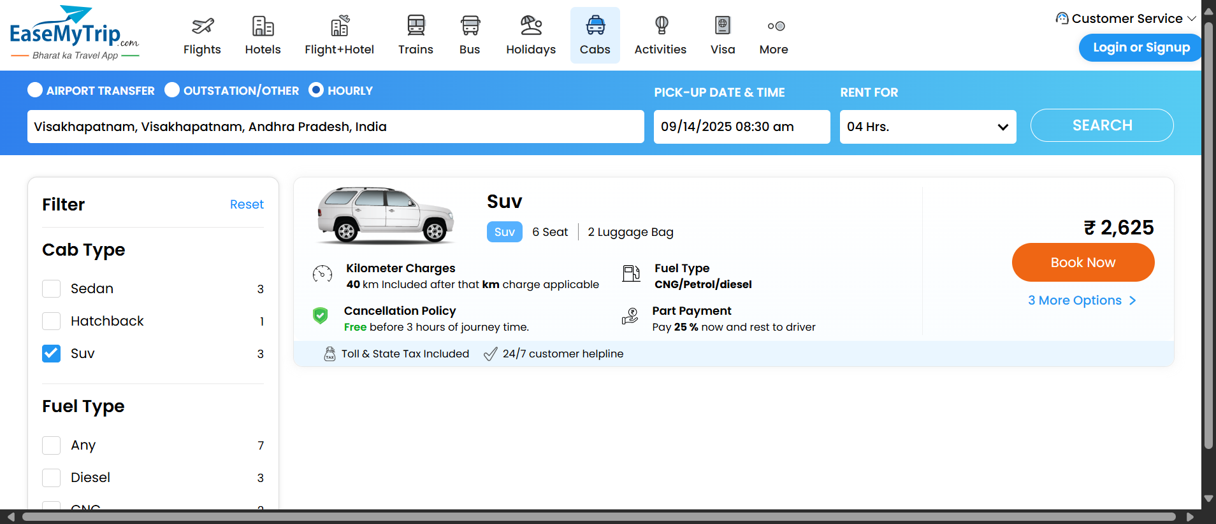

### **3.1.1.4 Req0004 – Cab Booking: Outstation Travel Flow**

This requirement describes the process for booking an outstation cab through the "EaseMyTrip for travel booking" web application.

* **Req0004a** – The user navigates to the **Cabs** tab and selects the **Outstation** option.
* **Req0004b** – In the **From** textbox, the user enters “Munnar” and selects **Munnar** from the auto-suggestion list.
* **Req0004c** – In the **To** textbox, the user enters “Munnar” and selects **Munnar** from the auto-suggestion list.
* **Req0004d** – The user chooses a **pickup date** using the calendar widget and selects a **pickup time** from the dropdown.
* **Req0004e** – After clicking the **Search** button, the system displays a list of available cabs along with their names and prices.

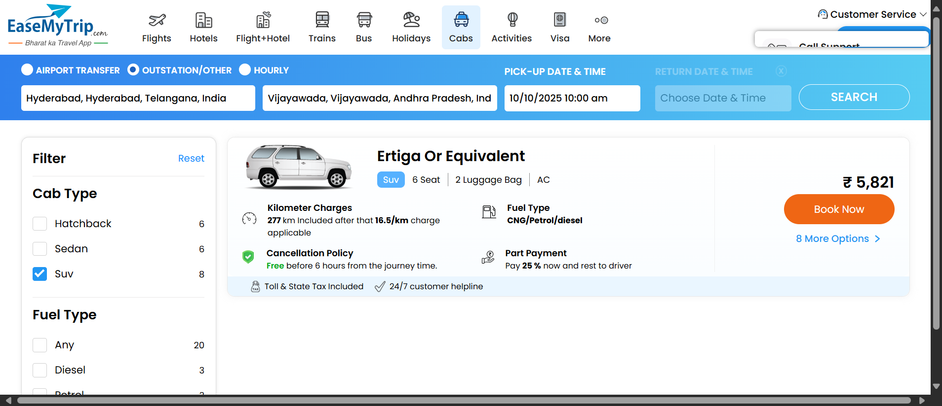

### **3.1.1.5 Req0005 – Cab Booking: Outstation Round Trip Flow**

This requirement outlines the process for booking a round-trip outstation cab via the "EaseMyTrip for travel booking" web application.

* **Req0005a** – The user navigates to the **Cabs** tab and selects the **Outstation** option.
* **Req0005b** – In the **From** textbox, the user enters “Munnar” and selects **Munnar** from the auto-suggestion list.
* **Req0005c** – In the **To** textbox, the user enters “Munnar” and selects **Munnar** from the auto-suggestion list.
* **Req0005d** – The user selects a **pickup date** using the calendar widget and chooses a **pickup time** from the dropdown.
* **Req0005e** – The user enables the **Round Trip** option, then selects a **return date** from the calendar and a **return time** from the dropdown.
* **Req0005f** – Upon clicking the **Search** button, the system displays a list of available cabs along with their names and prices.

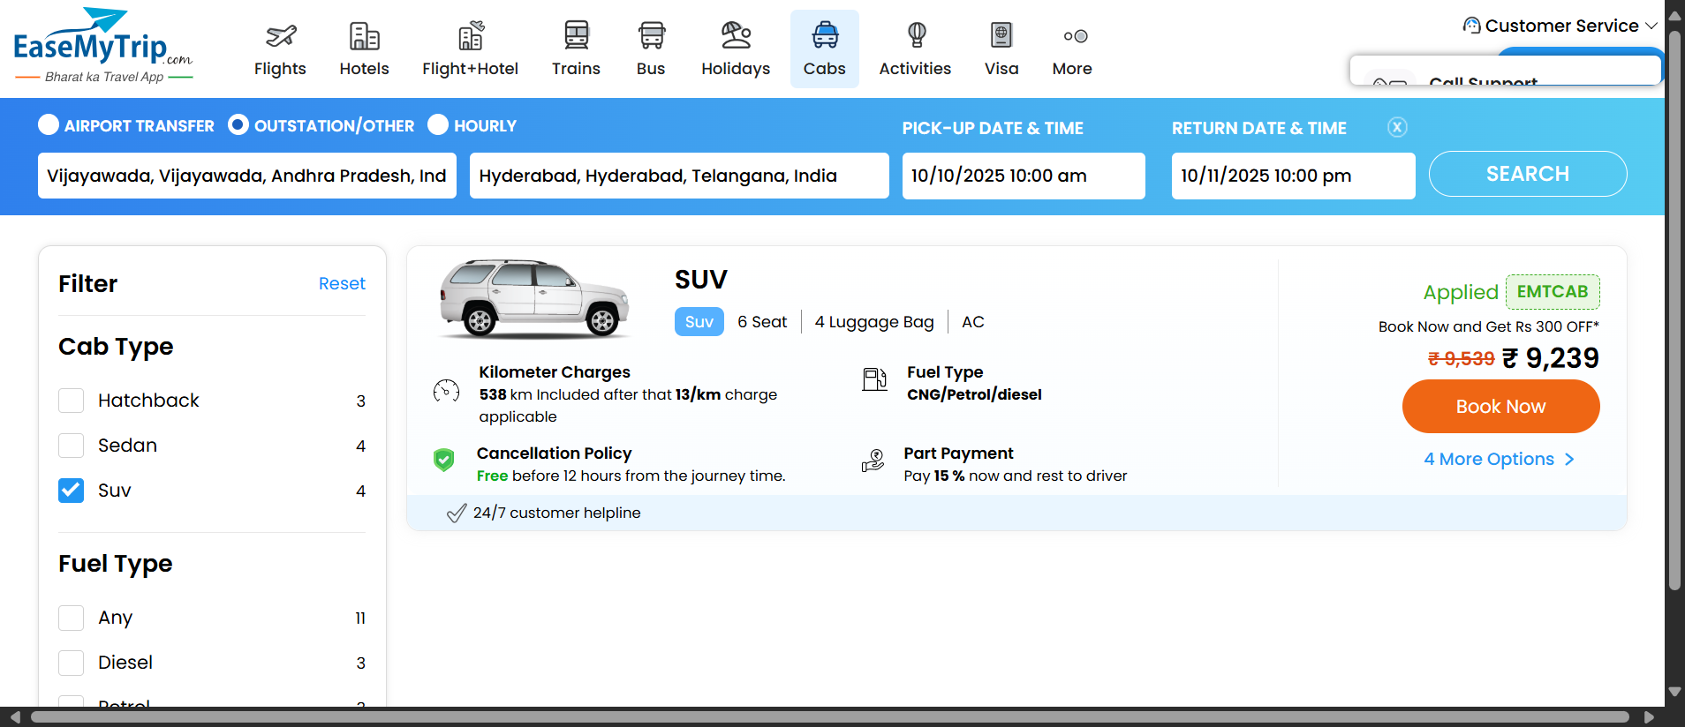

### **3.1.1.6 Req0006 – Activity Search: Invalid Location Input Flow**

This requirement outlines the behavior of the "EaseMyTrip for travel booking" web application when a user attempts to search for activities with incomplete location input.

* **Req0006a** – The user navigates to the **Activities** tab.
* **Req0006b** – In the **Where?** textbox, the user enters the partial text “Ba”.
* **Req0006c** – The user selects a **month**, **year**, and **date** from the calendar widget.
* **Req0006d** – Upon clicking the **Search** button, the system displays an **error message** indicating that the location input is invalid or incomplete.

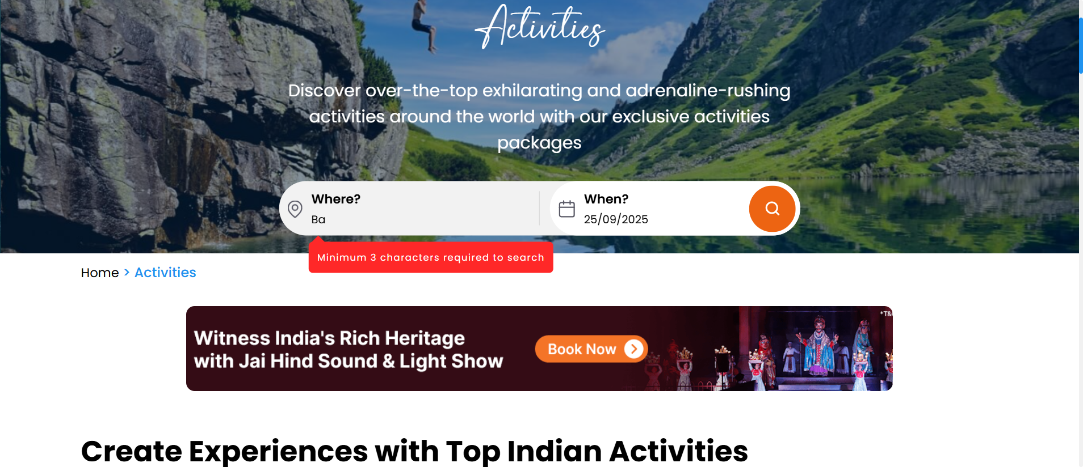

**3.1.1.7 Req0007 – Activity Search: Valid Location Input Flow**

This requirement defines the user interaction for searching activities in a valid location using the "EaseMyTrip for travel booking" web application.

* **Req0007a** – The user navigates to the **Activities** tab.
* **Req0007b** – In the **Where?** textbox, the user enters “Delhi” and selects **New Delhi** from the auto-suggestion list.
* **Req0007c** – The user selects the desired **month**, **year**, and **date** using the calendar widget.
* **Req0007d** – Upon clicking the **Search** button, the system displays a list of available activities matching the selected criteria.

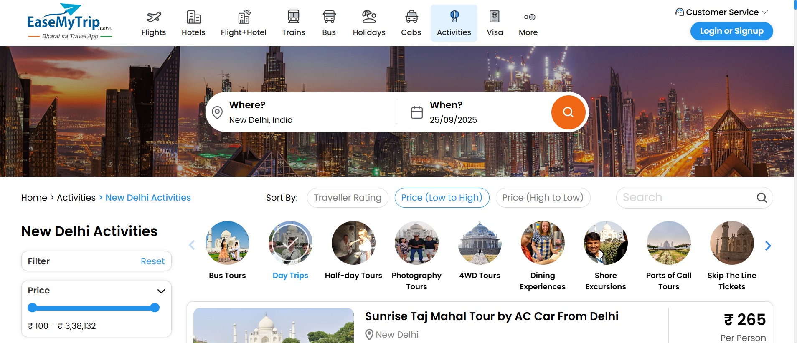

### **3.1.1.8 Req0008 – Hotel Booking Flow**

This requirement outlines the steps for searching hotels using the "EaseMyTrip for travel booking" web application.

* **Req0008a** – The user navigates to the **Hotels** tab.
* **Req0008b** – In the **City** textbox, the user enters “Delhi” and selects **Dwarka** from the auto-suggestion list.
* **Req0008c** – The user selects a **Check-In date** using the calendar widget.
* **Req0008d** – The user selects a **Check-Out date**, specifies the number of **Rooms & Guests** from the dropdown, and clicks the **Done** button.
* **Req0008e** –Upon clicking the **Search** button, the system displays a list of available hotels along with their names and prices.

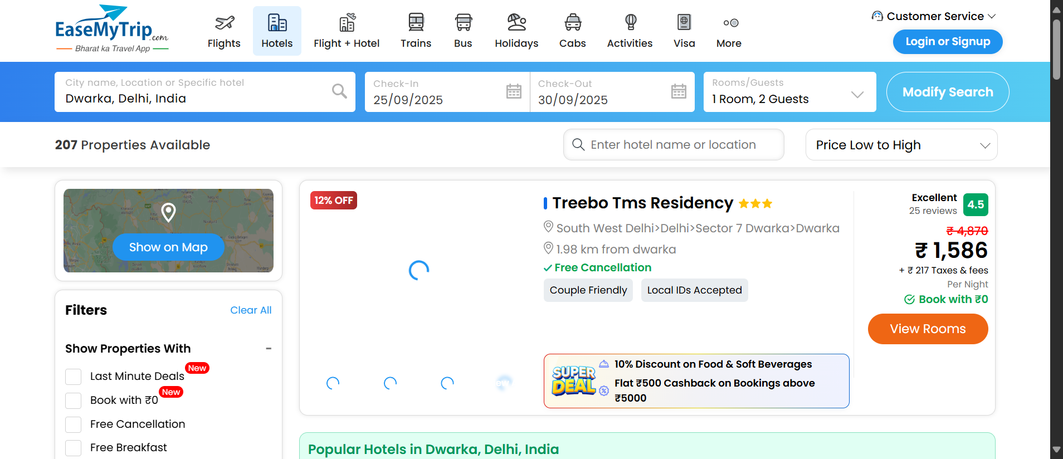

**3.1.1.9 Req0009 – Gift Card Purchase: Invalid Email Validation Flow**

This requirement outlines the user interaction for purchasing a festival gift card and the system’s response to invalid input in the "EaseMyTrip for travel booking" web application.

* **Req0009a** – The user hovers over the **More** tab and selects **Gift Card**.
* **Req0009b** – The user hovers over the **Festival** category and clicks to open the festival options.
* **Req0009c** – The user selects **Diwali** and scrolls down to access the gift card form.
* **Req0009d** – The user fills in the required details up to the **Sender’s Name** field.
* **Req0009e** – The user enters an **invalid email address** and a **valid mobile number**.
* **Req0009f** – After checking the **“I accept the terms and conditions”** checkbox, the system displays an **error message** due to the invalid email input and captures a **screenshot** of the error message display.

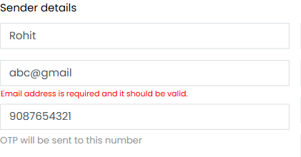

### **3.1.1.10 Req0010 – Gift Card Purchase: Invalid Mobile Number Validation Flow**

This requirement describes the user interaction for purchasing a festival gift card and the system’s response to an invalid mobile number input in the "EaseMyTrip for travel booking" web application.

* **Req0010a** – The user hovers over the **More** tab and selects **Gift Card**.
* **Req0010b** – The user hovers over the **Festival** category and clicks to view available festival options.
* **Req0010c** – The user selects **Diwali** and scrolls down to access the gift card form.
* **Req0010d** – The user fills in the required details up to the **Sender’s Name** field.
* **Req0010e** – The user enters a **valid email address** and an **invalid mobile number**.
* **Req0010f** – After checking the **“I accept the terms and conditions”** checkbox, the system displays an **error message** indicating the invalid mobile number and captures a **screenshot** of the error message display.

